The Reimagining of a Forgotten Romantic Voice: A Transcription of Emilie Mayer’s Violin Sonata in A Minor for Bassoon Handout
______________________________________________________________________________

Emilie Mayer’s General Information:
- 1812-1883
- Daughter to a widowed, apothecary father
- Studied composition with
  - Carl Loewe (early)
  - Adolf Bernhard Marx, Berlin (later)
  - Wilhelm Wieprecht, Berlin, orchestration
- One of very few women that composed for orchestra
- Never married
- Self-promoted through travelling and paying for her own publications
- Published through Bote & Bock and Challier

Emilie Mayer’s Compositions:

Works for Piano:
- Allemande fantastique, Op.29a
- Tonwellen Waltz, Op.30
- Ungaraise, Op. 31
- Waltz, Op. 32
- Mazurka, Op. 33
- Three Humors, Op. 41
- Impromptu, Op. 44
- Piano Sonata in D minor
- Concert Piece in B Major
- Six Piano pieces for children, Op. 48a
- Symphony in B minor (arr. A. Jurke), o. O.
- String Quartet in F Major arranged for four-handed piano
- String Quartet in D minor arranged for four-handed piano (edited)
- Marcia funebre (f. Blasinsr.) for four-handed piano
- Sonata in D minor
- Sonata in D Major
- Marcia in A Major
- Dances with two hands for the pianoforte
  - No. 1: Gallop-B Major; 2/4
  - No. 2: Gallop-A Major; 2/4
  - No. 3: Slower Waltz-A Major; ¾
  - No. 4: Slower Waltz-E Major; ¾
  - No. 5: Waltz-B Major; ¾
  - No. 6: Waltz-G Major; ¾
  - No. 7: Gallop-F Major; 2/4
  - No. 8: Scottish [Dance]-B Major; 4/8
  - No. 9: Eccosaise-D Major; 2/4
- Studies and Sketches: 1. Overture and 2. Sinfonia (partial)
Works for Voice:
- 2 Gesänge
- 3 Songs for Soprano or Tenor and Piano, Op.7
- 3 Humoresken, Op. 41
- Der Erlkönig
- Hungaraise, Op. 31
- “Die Fischerin” (Singspiel based on the text by Goethe)
- “Fünf Gesänge” for male voices, Op. 6 (lost in the war)
- “La Modesta” (Ed. Kühn), Op. 45 (lost in the war)
- Two Chants for one male voice and piano, o. O.
- Two children’s songs: “For the Joyful Youth, o. O.
- 23 Songs for male voices
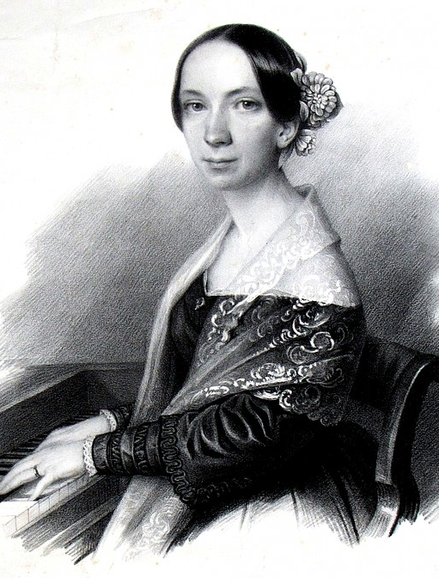
- Musikaliches Allerley (Composition Studies)
Works for Cello:
- Sonata in C Major, Op. 40
- Sonata in D Major, Op. 47
- Sonata in F Major
- Sonata in C minor (partial)
- Sonata in D minor (partial)
- Sonata in E minor (partial)
- Sonata in A Major (partial)
- Sonata in B Major (partial)
- Sonata in B minor (partial)
Works for Violin:
- Notturno, Op. 48
- Sonata in F Major, Op. 17
- Sonata in A minor, Op. 18
- Sonata in E minor, Op. 19
- Sonata in A Major, Op. 21 (lost in the war)
- Sonata in D minor, Op. 29
- Notturno in D minor (partial)
- Sonata in Eb Major
- Sonata in C minor (partial)
- Sonata in D Major (partial)
- Sonata in F# minor (partial)
Chamber Works:
- String Quartet No. 2 in D Major (partial, strings only)
- String Quartet in G minor, Op.14
- String Quartet in E minor (partial)
- String Quartet in D minor (partial)
- String Quartet in C Major (partial, incomplete)
- String Quartet in F Major (partial)
- String Quartet in G minor (partial)
- String Quartet in A Major (partial, Cello part in Ab Major)
- String Quartet in B Major (partial)
- Piano Trio, Op. 12
- Piano Trio in D Major, Op. 13 (lost in the war except violin part)
- Piano Trio in B minor, Op. 16 (lost in the war)
- Piano Trio in D minor (partial)
- Piano Trio in E minor (partial)
- Piano Trio in A minor (partial)
- Piano Trio in B major (partial)
- Piano Quartet in Eb Major (partial, strings, only)
- Quartet in G minor, Op. 14
Orchestral Works:
- Faust-Overture, Op.46
  - Faust-Overture for Piano (arr. B. Knetsch), Op. 46a
- Overture No. 2 in D minor (partial, strings only)
- Overture No. 3 in C Major (partial, strings only, incomplete)
- Overture in D minor (partial, strings only)
- Symphony No.1 in C minor (partial)
- Symphony No.2 in E minor (partial)
- Military Symphony No.3 in C major (partial, strings only)
- Symphony No.4 in B minor
- Symphony in E Major (partial)
- Symphony in f minor (partial, strings only)
From the Tappert Estate:
- Elf King for a string instrument and piano (c. 1842)
- Elf King for a string instrument and piano (1870)
Handwritten Transcripts:
- String Quartet I in D minor (violin part)
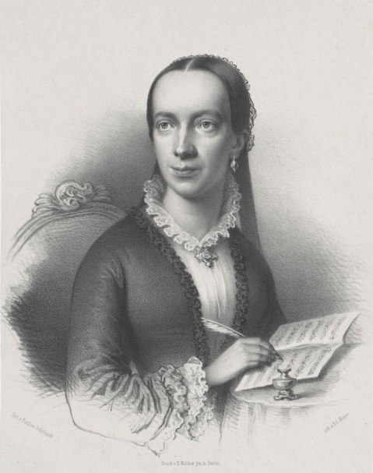
- Piano Quartet in Eb Major (strings)
- String Quartet IV in D Major, piano arrangement
- Piano Trio I in E minor (strings)
- Piano Trio II in D minor (strings)
- Piano Trio III in Eb Major (strings)
- Cello Sonata in F Major (string part)

All works cataloged and translated from Almut Runge-Woll’s book Die Komponistin Emilie Mayer (1812-1883): Studien zu Leben und Werk (The Composer Emilie Mayer (1812-1883): Studies on Life and Work), pp. 334-336.

